atom 10000 bucket 500 GPU

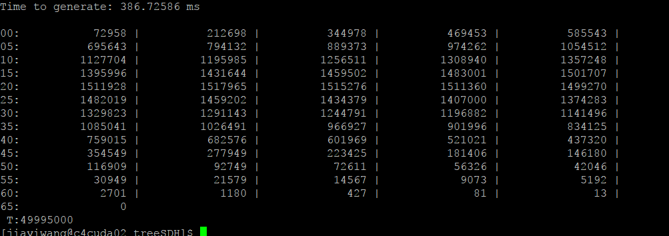

atom 10000 bucket 500 CPU

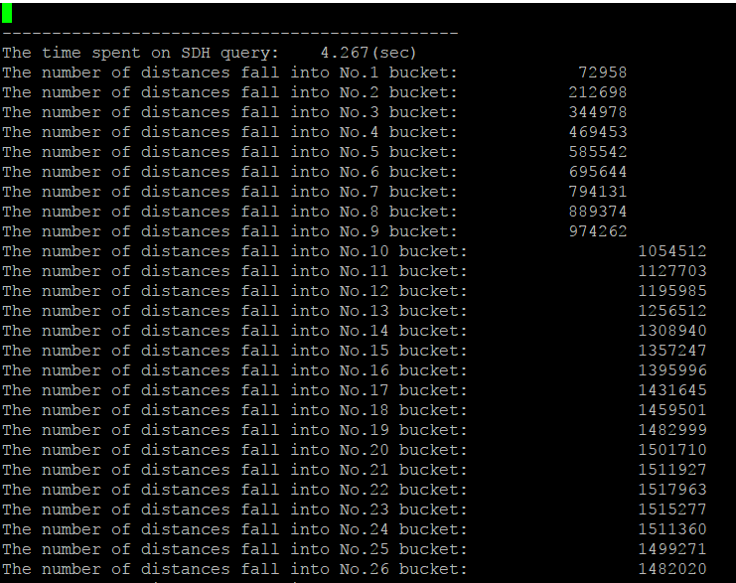

atom 100,000 bucket 1,000 CPU

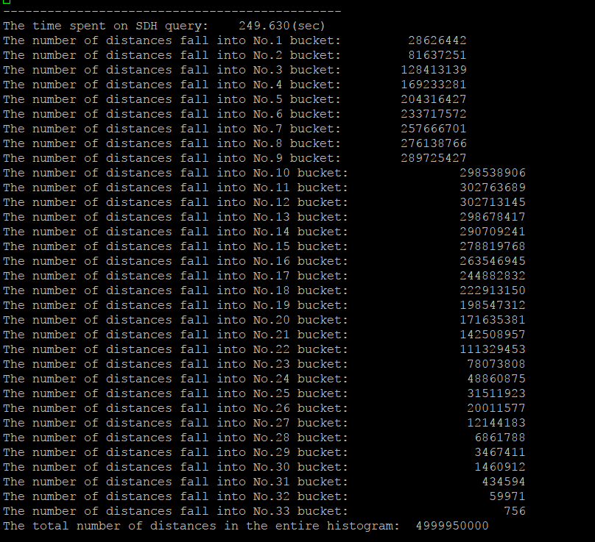

atom 100,000 bucket 1,000 GPU

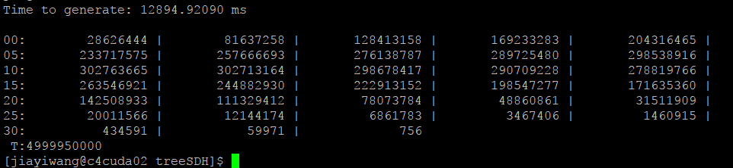

atom 100000 bucket 500 CPU

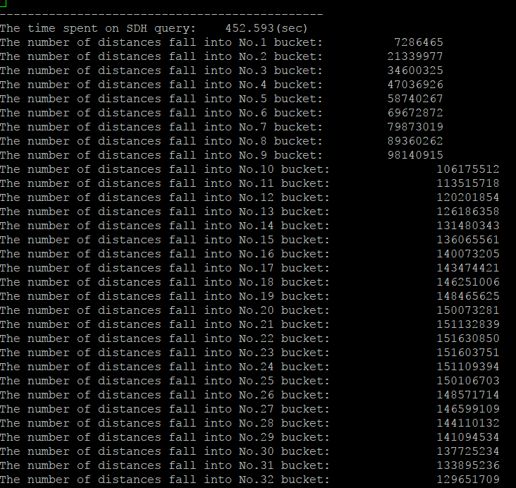

atom 100000 bucket 500 GPU

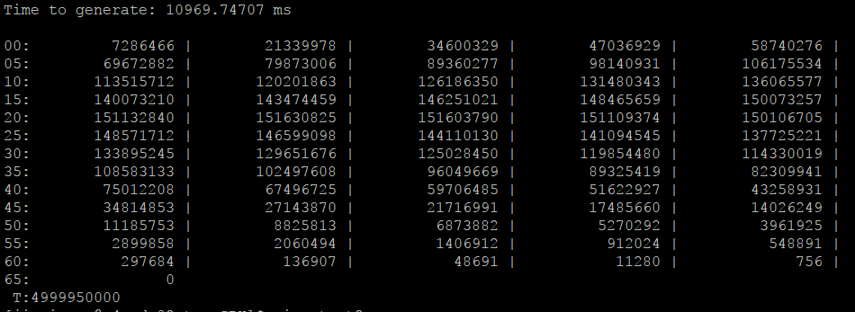

atom:10000 bucket 5000 CPU

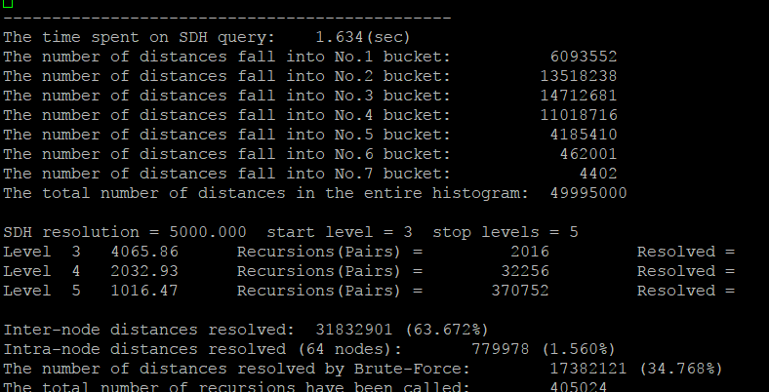

atom:10000 bucket 5000 GPU

